Email OTP – Step by Step
Important Notice – You only need One Device for this type of MFA. Smart phone/iPad/Tablet/ Laptop/Desktop
The Process will not start until you click continue on the instructions page
Once you open the link you will be brought to the Instructions Page. Where it will tell you on the top right what method of MFA you will be doing. On the Instruction Page you will have the chance to watch a video demonstrating the task. It also gives you what you need to do in written terms as well.
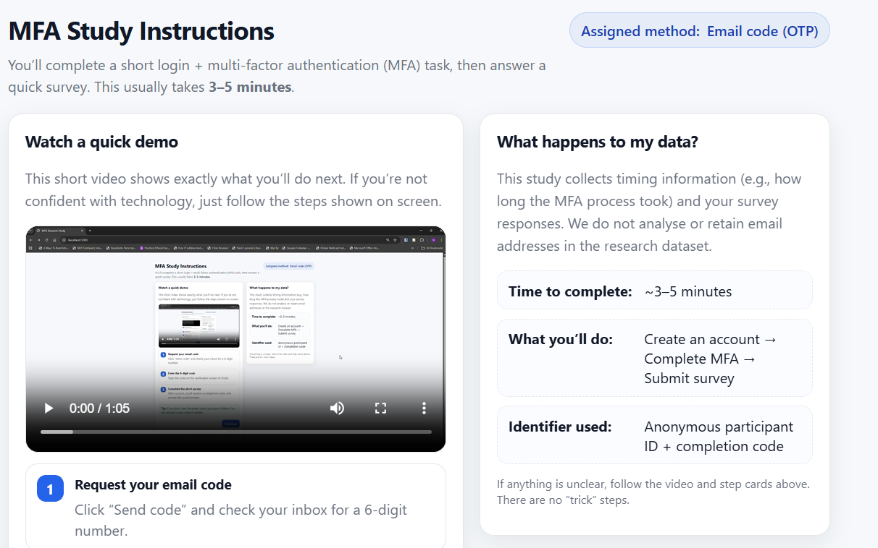
Then when you are ready to begin click the continue button.
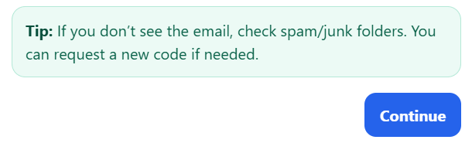

Sign-Up Page
Once you have pressed continue you will be brought to the Sign-Up page.
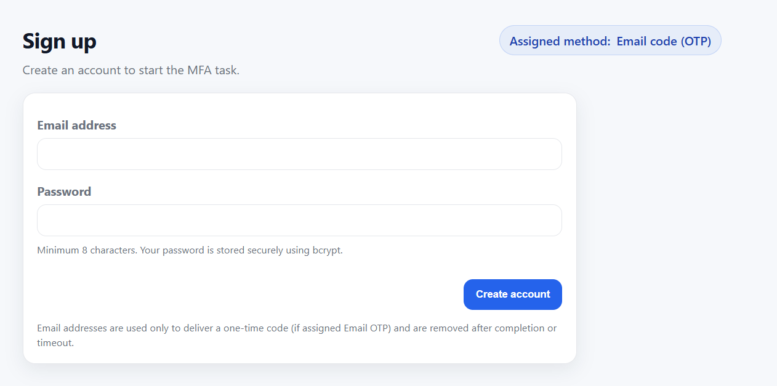
Please enter your email and then a password which needs to be a minimum of 8 characters. Your passwords are hashed but please do not use any passwords you normally use. Just use a random password for this process. Once you have entered a Username and password click create account.
Verify Email Code Page
The Verify Email Code page will be load, click the Send Code button and then navigate to your emails.
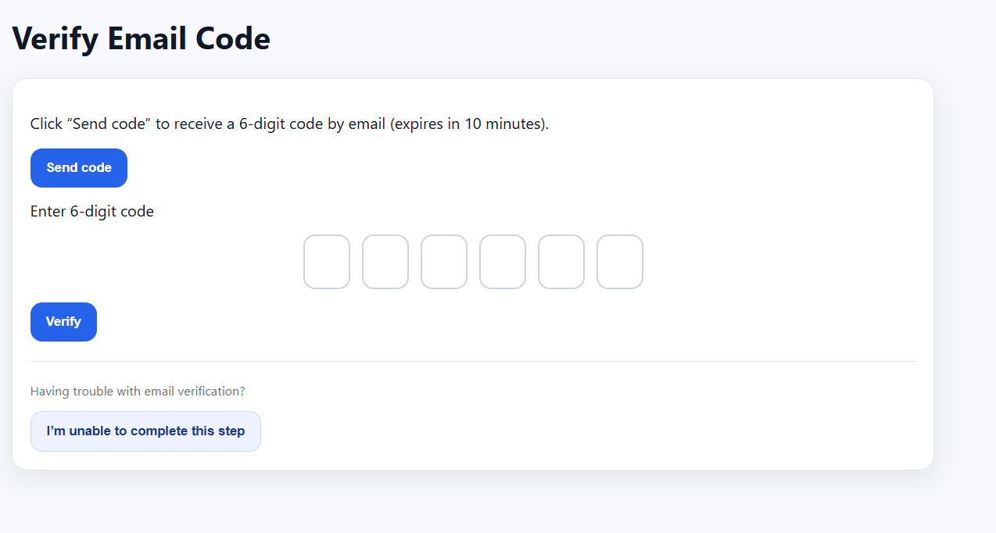

You will receive an email from mfa.research.study@gmail.com. It will display your six-digit code.
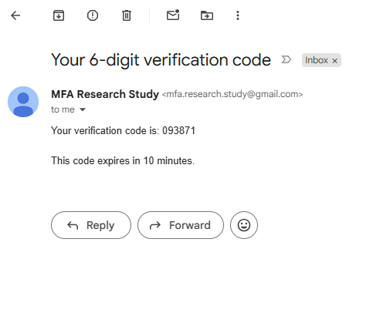
Enter the six digit code into the boxes provided and then click verify.
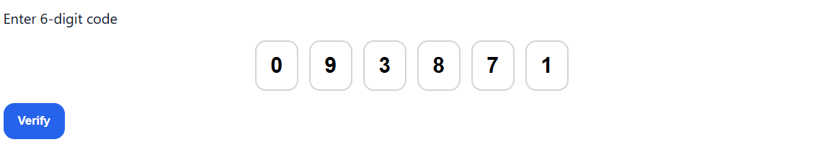
If at this point you are struggling to complete the step you can click on the ‘I am unable to complete this step’ button. Which will take you to the questionnaire page, you will have additional questions to answer at the bottom of the questionnaire.
Questionnaire
You will then go to the questionnaire page. You will all be given a unique completion code on the page but you don’t need to worry about entering the code into Q1 as it has already been done for you.
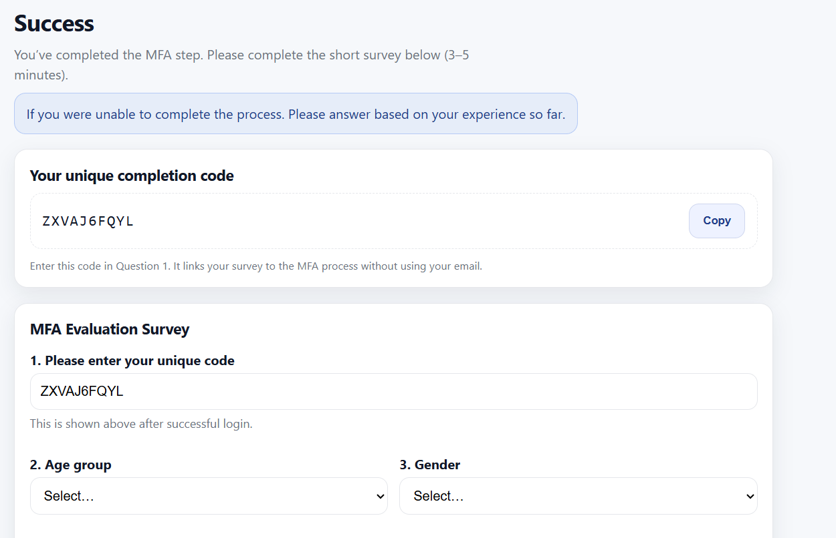
Answer all the questions accordingly and once you have completed the questionnaire click the submit button.
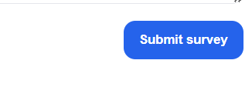
Thank You page
When you click submit you will then be brought to the Thank you page and you will see that your questionnaire response has been successfully submitted. Thank you to everyone who takes their time out to participate it means a lot.
